

**Web Application Security Testing**

Web applications are unique constructs, mixing various forms of technology and providing an interactive front for others to use. Some web applications are made public, while others might be internal applications existing on an intranet. No matter the location, there are always security vulnerabilities. How well does your application handle input? Does it work with backend servers in a secure manner? Will your session management scheme hold up to penetration testing?

Web application penetration testing at Securze tests for the following:

* Application logic flaws
* Forced browsing
* Access and authentication controls
* Session management
* Cookie manipulation
* OWASP Top 10
* Horizontal escalation
* Vertical escalation
* Brute-force password guessing
* Poor server configuration
* Information leakage
* Source code disclosure
* Response splitting
* File upload/download attacks
* Parameter tampering
* URL manipulation
* Injection attacks for HTML, SQL, XML, SOAP, XPATH, LDAP, Command
* Cross-site scripting
* Fuzzing
* Cryptographic Issues
* Memory Corruption
* CVE
* Secure Design
* Manual tests

**Methodology:**

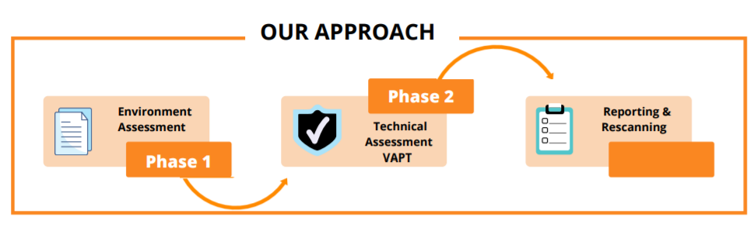

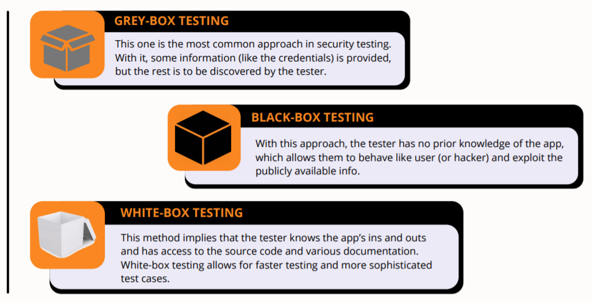

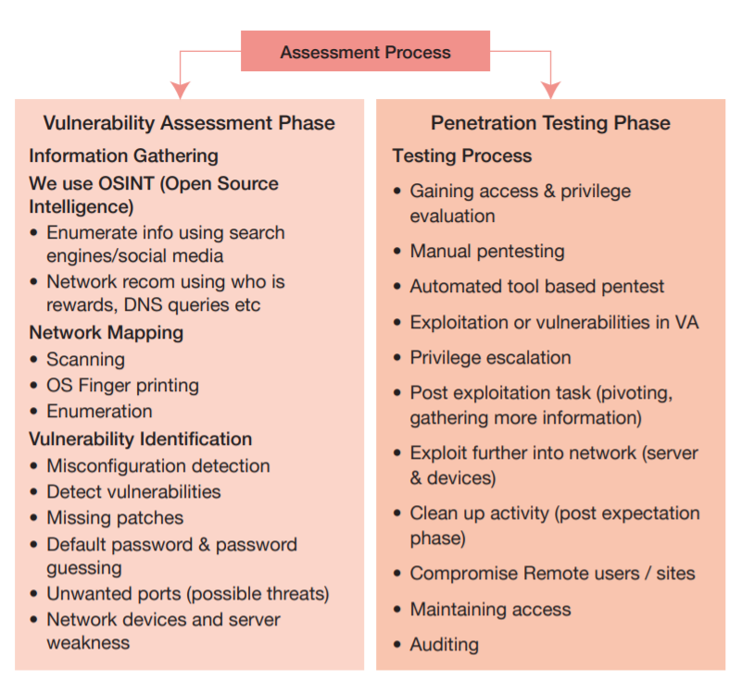

**Package Details & Pricing:**

|  |  |  |  |
| --- | --- | --- | --- |
|  | Start-up Package  $– 1 Time | Corporate  $– 1 Time | Corporate Pro  $ – 1 Time |
| GDPR | Keywords Advantage | Free Emojis For Amazon Listing Titles, Bullet Point  Features and Description | Keywords Advantage | Free Emojis For Amazon Listing Titles, Bullet Point  Features and Description | Keywords Advantage | Free Emojis For Amazon Listing Titles, Bullet Point  Features and Description |
| Managed vulnerability scan | Keywords Advantage | Free Emojis For Amazon Listing Titles, Bullet Point  Features and Description  **(Basic)** | Keywords Advantage | Free Emojis For Amazon Listing Titles, Bullet Point  Features and Description  **(Advance)** | Keywords Advantage | Free Emojis For Amazon Listing Titles, Bullet Point  Features and Description  **(Advance)** |
| OWASP Top 10 | Keywords Advantage | Free Emojis For Amazon Listing Titles, Bullet Point  Features and Description | Keywords Advantage | Free Emojis For Amazon Listing Titles, Bullet Point  Features and Description | Keywords Advantage | Free Emojis For Amazon Listing Titles, Bullet Point  Features and Description |
| SANS Top 25 detection |  |  | Keywords Advantage | Free Emojis For Amazon Listing Titles, Bullet Point  Features and Description |
| Application logic testing |  | Keywords Advantage | Free Emojis For Amazon Listing Titles, Bullet Point  Features and Description | Keywords Advantage | Free Emojis For Amazon Listing Titles, Bullet Point  Features and Description |
| Web Application Firewall bypass |  |  | Keywords Advantage | Free Emojis For Amazon Listing Titles, Bullet Point  Features and Description |
| Target Scope | **Up to 1 Web Application** | **Upto 1 Web Applicattion** | **Up to 1 Web Application** |
| Zero false-positives guaranteed | Keywords Advantage | Free Emojis For Amazon Listing Titles, Bullet Point  Features and Description | Keywords Advantage | Free Emojis For Amazon Listing Titles, Bullet Point  Features and Description | Keywords Advantage | Free Emojis For Amazon Listing Titles, Bullet Point  Features and Description |
| CWE, CVE and CVSS compliance | Keywords Advantage | Free Emojis For Amazon Listing Titles, Bullet Point  Features and Description | Keywords Advantage | Free Emojis For Amazon Listing Titles, Bullet Point  Features and Description | Keywords Advantage | Free Emojis For Amazon Listing Titles, Bullet Point  Features and Description |
| GDPR | Keywords Advantage | Free Emojis For Amazon Listing Titles, Bullet Point  Features and Description | Keywords Advantage | Free Emojis For Amazon Listing Titles, Bullet Point  Features and Description | Keywords Advantage | Free Emojis For Amazon Listing Titles, Bullet Point  Features and Description |
| Different user roles testing |  | Keywords Advantage | Free Emojis For Amazon Listing Titles, Bullet Point  Features and Description | Keywords Advantage | Free Emojis For Amazon Listing Titles, Bullet Point  Features and Description |
| Pentest Reports | Keywords Advantage | Free Emojis For Amazon Listing Titles, Bullet Point  Features and Description | Keywords Advantage | Free Emojis For Amazon Listing Titles, Bullet Point  Features and Description | Keywords Advantage | Free Emojis For Amazon Listing Titles, Bullet Point  Features and Description |
| Dedicated Consultant | Keywords Advantage | Free Emojis For Amazon Listing Titles, Bullet Point  Features and Description | Keywords Advantage | Free Emojis For Amazon Listing Titles, Bullet Point  Features and Description | Keywords Advantage | Free Emojis For Amazon Listing Titles, Bullet Point  Features and Description |
| Customizable | Keywords Advantage | Free Emojis For Amazon Listing Titles, Bullet Point  Features and Description | Keywords Advantage | Free Emojis For Amazon Listing Titles, Bullet Point  Features and Description | Keywords Advantage | Free Emojis For Amazon Listing Titles, Bullet Point  Features and Description |

[**Click Here**](https://forms.gle/c4RrBJiaFw6xonKF9) **to inquire more about our other services.**



**Email:** [**contact@securze.com**](mailto:contact@securze.com)

**Phone Number: +91 8454051344 / +91 8451073938**

**Website:** [**https://securze.com**](https://securze.com)